**SEIS630 Database Final Project Draft**

**Point-of-Sale Database Project**

***Avinash Verma***

***101261924***

---------------------------------------------------------------------------------------------------------------------------------------------

**Introduction:**

On the Retail Store dataset, this is designed to construct a database system for the Point-of-Sale system. Products, Sales Details, Inventory, Returns Details, Replenishment Order, and User Login would have been included in the product. It can be used with any **POINT-OF-SALE** billing system in a retail establishment.

I chose this topic for my project because I came from a business family and would like to use it to tackle some of my store's challenges. As a result, I wanted to work on something relevant to my passion. This project also allows me to gain hands-on experience with a variety of tools covered in class, including SQL, SQL Developer, Python, and Oracle Data Modeler.

1. **Planning:**

* Choose the RETAIL STORE dataset from my python project and explore the data.
* To design database use ER strategy and create a logical and relational diagram over Oracle Data Modeler.
* Proceed through the normalizing procedure to create a set of tables.
* AWS RDS MySQL and MySQL Workbench can be used to create and maintain the database schema and normalized tables.
* Research on how connect PYTHON with AWS database.
* The population of database from csv to master table can be done through single insert query in python.
* Formulate SQL queries for basic and deep search.
* Executing those queries using PYTHON.
* Connect the database to PYTHON.

1. **Exploring:**

* Data collection:

The data is used from the python dataset which I got from Prof. Syed Ali Naqvi in Fall 2022. This is an open dataset and could be used for further project. The content of the datasets are as follows in screenshot:

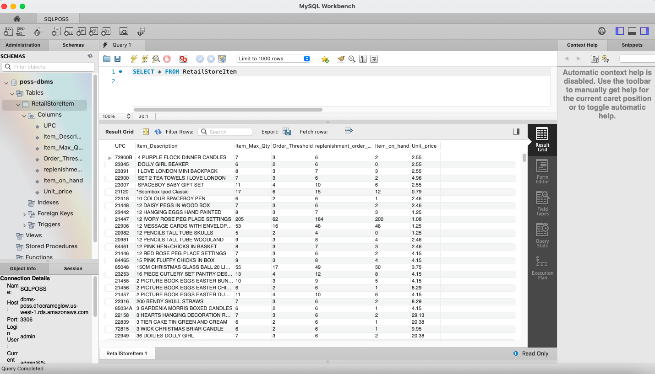

1. **Building:**

* For the database I have used AWS RDS MySQL database.
* For creating the Logical and Relational diagram I have used Oracle Data Modeler.
* For writing the DDL and DML queries to enter the data in table I have used PYTHON.
* I have used MySQL Workbench to create the tables.
* I have created a connection between python and MySQL.
* I have uploaded the data into the tables from PYTHON SQL query.

**Learnings:**

These learnings I have applied while creating and completing this project as per guidelines:

1. **Database:**

I have selected the AWS RDS MySQL database for my project and creating the database in it.

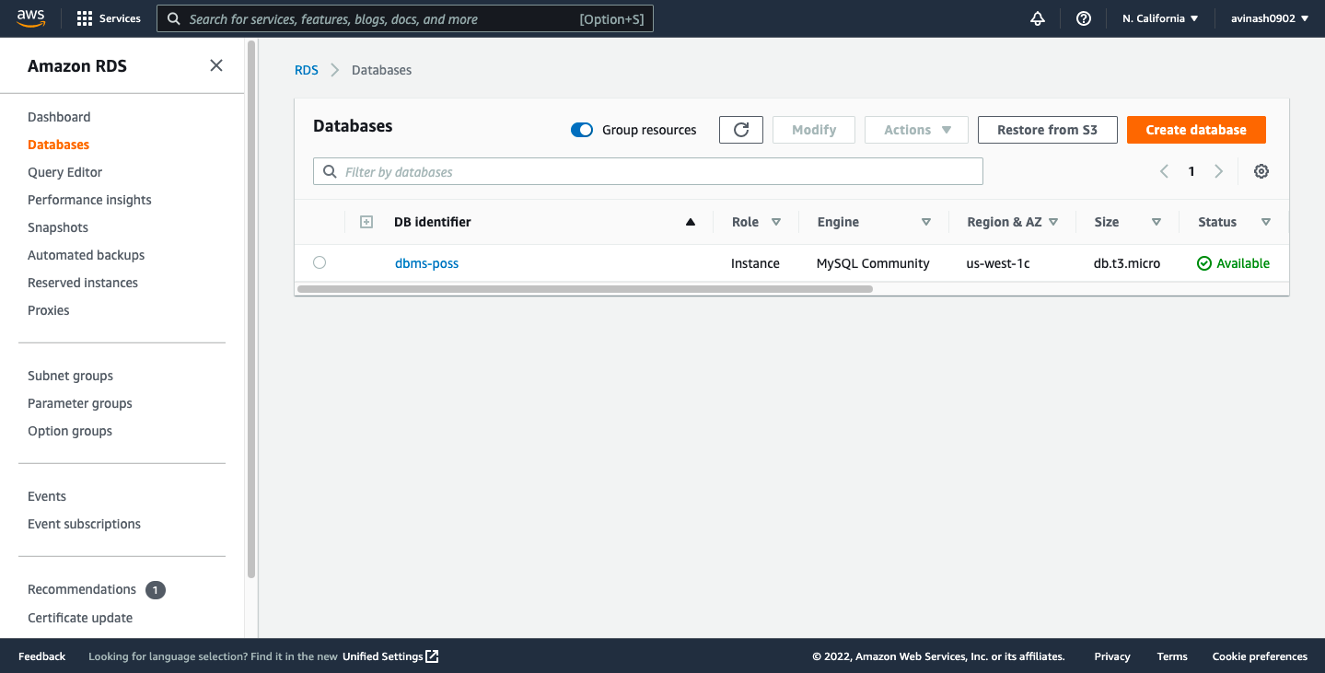

1. **Python Connection:**

I have created the connection between database and python.

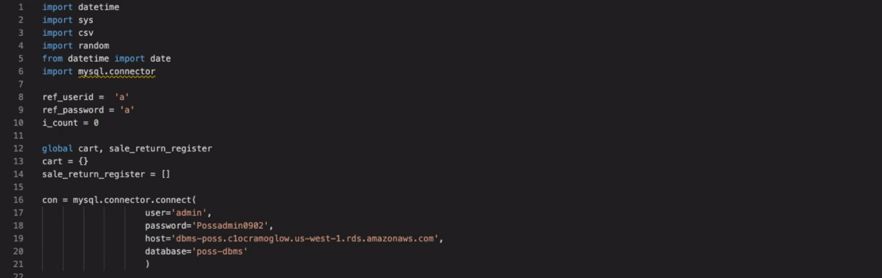

1. **Normalization:**

I have Retail Store dataset with10 columns. There are 3 blank columns in the dataset. By normalizing the data set we have removed blank columns from the dataset and have made that dataset more consistent for further updates. We have created 2 other tables and normalized into 2nd normal form.

1. **Data Modeling and DDL commands:**

Oracle Data Modeler was used to develop the data model. For the normalized dataset, I constructed a logical and relational diagram. I created CREATE, UPDATE, DROP, and ALTER tables using SQL's Data Definition Language commands that we learned in class. Constraints like PRIMARY Key, FOREIGN Key have also been used.

* + - **Logical:**

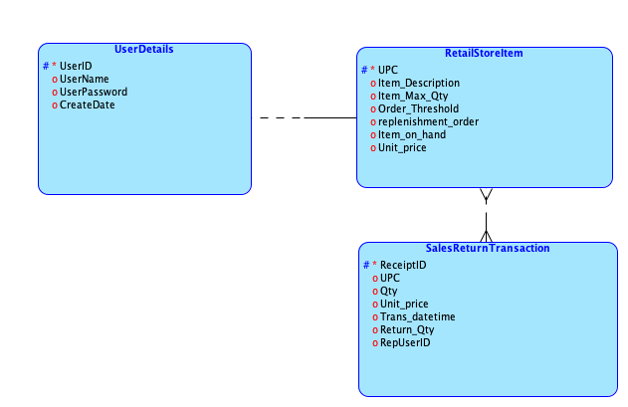

* + - **Relational:**

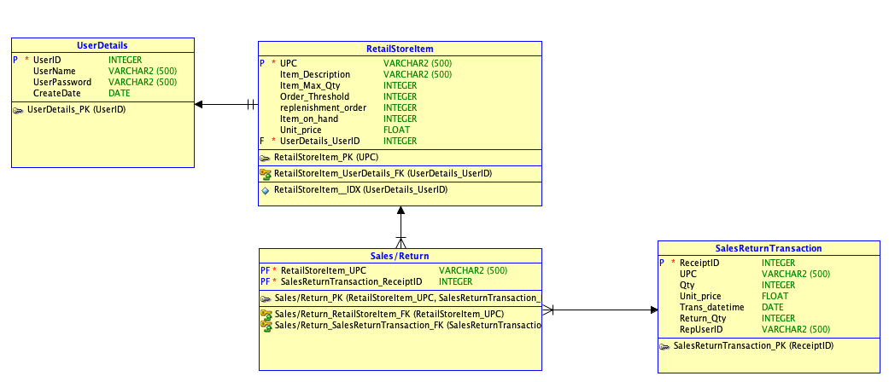

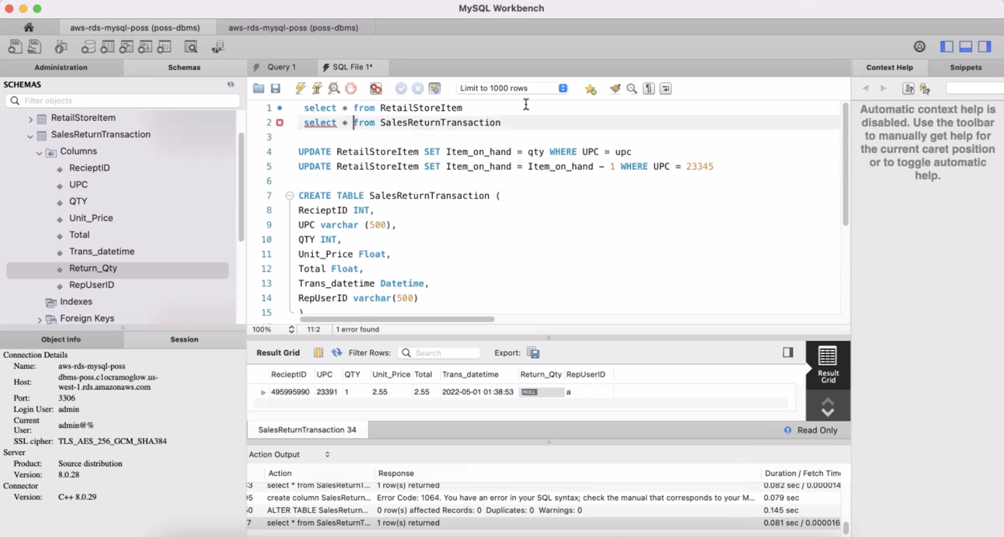

1. **DML and DQL commands:**

We must next populate the tables with data once they have been created. To populate and update data in tables, I've used DML commands like INSERT and UPDATE. We must query the data using DQL commands like SELECT after the data has been populated. I used the INSERT query in Python for bulk updates.



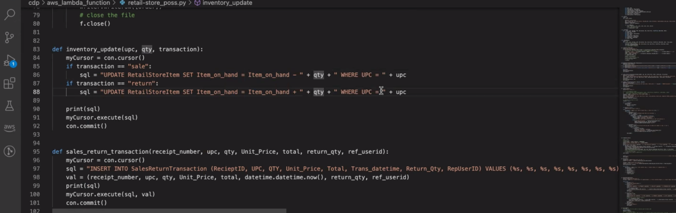

**Goal:**

According to my understanding of what we learned in class, the project is completed and operational. We covered data modeling, DDL, DML, and DQL commands in class. In addition, we looked into data normalization. We researched the viewpoints. The database connection has been investigated. We learned about Oracle Data Modeler and SQL Developer and practiced using them.

Although we did not go over how to connect a database to Python, we did go over data types briefly in class.

**Conclusion:**

Database Management and Design is an intriguing subject to take. I've never worked with databases before. My database skills have significantly improved after taking this course. I was unfamiliar with topics such as Database Python Connection, Normalization, Data Modelling, and Database Redesign. Advanced topics such as Django, Snowflake, Data Warehouses, Business Intelligence, and Big Data were thoroughly presented, expanding my understanding of databases and their applications in the Data Science arena.

Finally, I would like to express my gratitude to Professor Abe for providing us with the opportunity to work on projects of our choosing while learning about database possibilities. His expertise of databases, from the classic to the most recent, is outstanding, and he inspires others in the industry.